
COMSATS University Islamabad
Islamabad Campus
ECE 6
Subject: Data Communications & Computer Networks Marks: 30
Exam: Lab Sessional-2 Time: 60 Minutes
Instructor Asad Ali Malik Dated:06th May,2021

- Attempt all question.
- Email this word file on asadalimalik@comsats.edu.pk. Within due time which 60 minutes after receiving this paper.
- Late submissions will not be entertained.

Topology Diagram

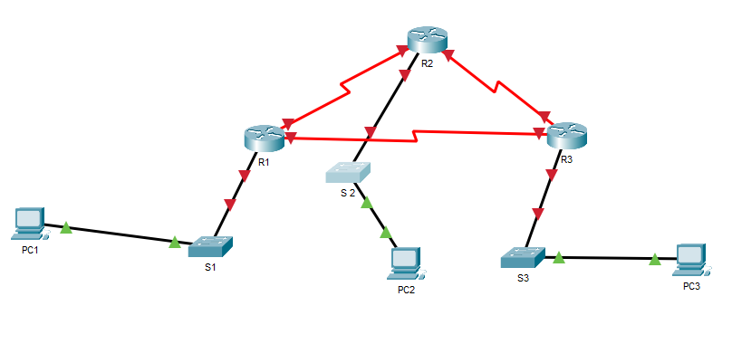

Given an IP address of 199.168.X.0/24, fill the table given below also fill the addressing table. Configure all interfaces and implement the routing protocol best suited also mention the reason behind your selection of a particular protocol. (‘X’ in IP is the registration number of each student. Hint: fill in first six and last)

Student Name: Muhammad Haris Irfan

Registration Number: FA18-BCE-090

No. of useable subnetworks: 8
No. useable Hosts per networks: 30
Subnet Mask: 255.255.255.224/27

# | Subnet | First host address | Last host address | Broadcast Address
1 | 199.168.90.0 | 199.168.90.1 | 199.168.90.30 | 199.168.90.31
2 | 199.168.90.32 | 199.168.90.33 | 199.168.90.62 | 199.168.90.63
3 | 199.168.90.64 | 199.168.90.65 | 199.168.90.94 | 199.168.90.95
4 | 199.168.90.96 | 199.168.90.97 | 199.168.90.126 | 199.168.90.127
5 | 199.168.90.128 | 199.168.90.129 | 199.168.90.158 | 199.168.90.159
6 | 199.168.90.160 | 199.168.90.161 | 199.168.90.190 | 199.168.90.191
Last | 199.168.90.224 | 199.168.90.225 | 199.168.90.254 | 199.168.90.255

Addressing table
Device | Interface | Ip Address | Subnet Mask | Default Gateway
R1 | Fast Ethernet | 199.168.90.1 | 255.255.255.224 | N/A
R1 | Serial interface | 199.168.90.33 | 255.255.255.224 | N/A
R1 | Serial interface | 199.168.90.65 | 255.255.255.224 | N/A
R2 | Fast Ethernet | 199.168.90.97 | 255.255.255.224 | N/A
R2 | Serial interface | 199.168.90.34 | 255.255.255.224 | N/A
R2 | Serial interface | 199.168.90.129 | 255.255.255.224 | N/A
R3 | Fast Ethernet | 199.168.90.161 | 255.255.255.224 | N/A
R3 | Serial Interface | 199.168.90.130 | 255.255.255.224 | N/A
R3 | Serial Interface | 199.168.90.66 | 255.255.255.224 | N/A
PC 1 |  | 199.168.90.2 | 255.255.255.224 | 199.168.90.1
PC 2 |  | 199.168.90.98 | 255.255.255.224 | 199.168.90.97
PC 3 |  | 199.168.90.162 | 255.255.255.224 | 199.168.90.161

Tasks
- Implement above network and routing in Packet Tracer
- Perform basic configuration tasks on each router
- Configure and activate Ethernet interfaces
- Include Output of show ip route command, show ip protocol command and show ip interface brief command.

